IT6425_Programming Lab Sheet 04

Read the problem description and examine the sample output; then study the template code (available from Moodle). Using the problem-solving tips as a guide, replace the /* */ comments with Java code. Compile and execute the program. Compare your output with the sample output provided. Then answer the follow-up questions. The source code for the template is available from Moodle.

Lab Objectives
This lab is designed to reinforce programming concepts from Chapter 7 of Java How to Program: In this lab, you will practice:
• Declaring and initializing arrays.
• Comparing input to array elements.
• Preventing array out-of-bounds errors.

The follow-up questions and activities will also give you practice:
• Initializing array sizes during program execution.
• Generalizing programs.

Problem Description
Use a one-dimensional array to solve the following problem:
Write an application that inputs five numbers, each of which is between 10 and 100, inclusive. As each number is read, display it only if it is not a duplicate of a number already read. Provide for the “worst case,” in which all five numbers are different. Use the smallest possible array to solve this problem. Display the complete set of unique values input after the user inputs each new value.
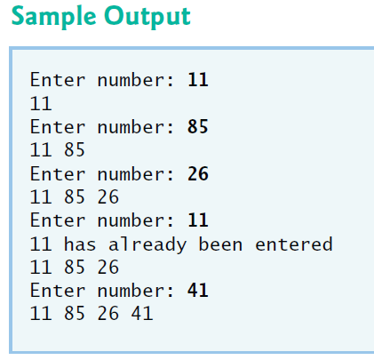

Problem-Solving Tips

Note: Download and use the source code template (available from Moodle) as starting point for this lab.
- Initialize the integer array numbers to hold five elements. This is the maximum number of values the program must store if all values input are unique.
- Remember to validate the input and display an error message if the user inputs invalid data.
- If the number entered is not unique, display a message to the user; otherwise, store the number in the array and display the list of unique numbers entered so far.

Follow-Up Activities

- Modify the program to input 30 numbers, each of which is between 10 to 500.
- Modify the program to allow the user to enter numbers until the array is full.
- Modify your solution to allow the user to enter the size of the array as the application.
IT6x23_Programming Lab Sheet 04  Hand this sheet to the lecturer for signing.  Due: 5:00 pm, Friday 22 September 2017 | Student ID: _________________________  Name: _________________________  Signature: ________________________  Date Submitted: ___________________
I have seen the tasks specified in this lab sheet running.

Signed by: _____________________________ Date: ___________________

